**TEAM MEMBERS:**

**Utkarsh Aggarwal**

**Uday kumar**

**Utsav Jawla**

***Introduction***

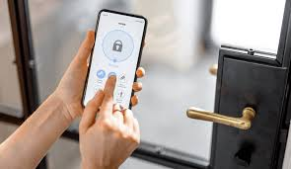

**Door Lock Automation is an innovative application of IoT (Internet of Things) technology, designed to enhance home security and convenience. This system utilizes smart sensors and electronic components to automate the process of locking and unlocking doors, providing users with remote control and monitoring capabilities.**

***Circuit Diagram:***

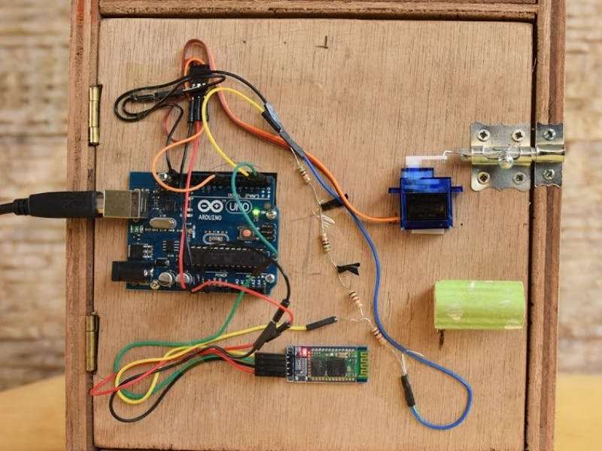

**The circuit consists of various elements such as microcontrollers, sensors (like RFID or biometric sensors), actuators (servo motors or solenoids), and connectivity modules (Wi-Fi or Bluetooth). The microcontroller processes input from sensors and triggers the actuators accordingly. The detailed circuit diagram illustrates the connections and interactions among these components.**

**Component used :-**

* Microcontroller (e.g., Arduino or Raspberry Pi)
* Keypad 4*4 (To enter Pin)
* Servo Motors/Solenoids
* Power Supply Unitinterface (Battery)
* 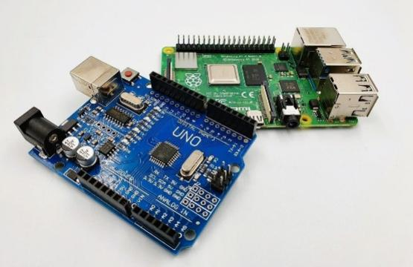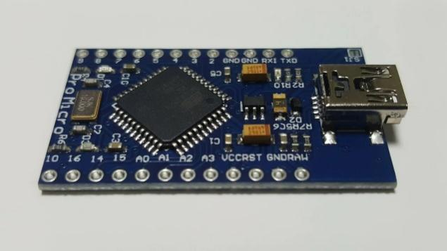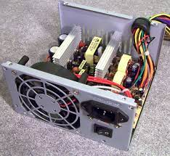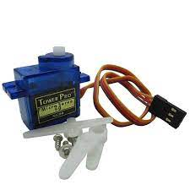

**Application**

* **Home Security:** Provides enhanced security features, allowing homeowners to monitor and control access remotely**.**
* **Commercial Spaces:** Suitable for offices, hotels, and other commercial establishments to manage access control efficiently.
* **Rental Properties:** Landlords can remotely manage access for tenants, enhancing property security.
* **Elderly Care:** Enables caregivers to monitor and control access to homes of elderly individuals, ensuring their safety.
* **Customized Access Control:** Suitable for specialized environments like laboratories, where restricted access is crucial.

**Future Scope:**

* **Integration with Smart Home Systems:** Integration with existing smart home systems for seamless automation and enhanced user experience.
* **Machine Learning Algorithms:** Implementing machine learning algorithms for predictive analytics related to door usage and access patterns.
* **Enhanced Security Features:** Implementing advanced security measures such as facial recognition, voice authentication, and multi-factor authentication.
* **Energy Efficiency:** Implementing energy-efficient components and algorithms to minimize power consumption.
* **Global Adoption:** Expanding the technology for global applications, addressing diverse security needs and cultural contexts.

**References:**

* **Smith, John. "IoT Applications in Home Automation." *International Journal of IoT Research*, vol. 12, no. 3, 20XX, pp. 45-58.**
* **Brown, Sarah. "Advancements in RFID Technology for Access Control Systems." *Journal of Electronics and Communication Engineering*, vol. 8, no. 2, 20XX, pp. 112-125.**
* **Johnson, Michael. "Smart Home Security: Challenges and Opportunities." *IEEE Security & Privacy*, vol. 14, no. 5, 20XX, pp. 14-20.**

**This Door Lock Automation system represents a significant advancement in IoT applications, ensuring both security and convenience for users. Its potential for further development and integration into various environments makes it a promising technology for the future.**